Configuring interVLAN Routing - Worksheet

Now that you have a working VLAN scenario, you have been asked to integrate the Team Rooms with the Provo network. You also want to give the Teams internet access. To accomplish this, you will configure interVLAN routing. Since you used your gigabit interfaces to link the Team switches, you need to increase bandwidth out of the Team Rooms using EtherChannel between Team 1 switch and ProvoDist switch. Most of your work will be done on the Provo network but a few items must be completed on the Team switches.
Here is the information you will need for the project:
IPv4 Assignments
PC Name | VLAN Name | VLAN Configuration
Sales 1 | Sales | 192.168.1.10
Marketing 1 | Marketing | 192.168.2.10
Admin 1 | Admin | 192.168.3.10
Sales 2 | Sales | 192.168.1.20
Marketing 2 | Marketing | 192.168.2.20
Admin 2 | Admin | 192.168.2.20
Sales 3 | Sales | 192.168.3.10
Marketing 3 | Marketing | 192.168.3.20
Admin 3 | Admin | 192.168.3.30

VLAN Information:
VLAN Information | Port Assignments
1 Management | 13-16
10 Sales | 1 – 4
20 Marketing | 5 - 8
30 Admin | 9 – 12

EtherChannel Configuration Commands:
The following table shows common commands to configure EtherChannel:
Command | Description
Switch(config-if)#channel-protocol lacp  Switch(config-if)#channel-protocol pagp | Selects the EtherChannel protocol on the interface.
Switch(config-if)#channel-group [1-8] mode auto  Switch(config-if)#channel-group [1-8] mode desirable | Selects the PAgP mode on the interface.
Switch(config-if)#channel-group [1-8] mode active  Switch(config-if)#channel-group [1-8] mode passive | Selects the LACP mode on the interface.
Switch(config-if)#channel-group [1-8] mode on | Enables the on mode and forces a port to join an EtherChannel without PAgP or LACP negotiations.
Switch(config-if)#no channel-group [1-8] | Disables EtherChannel on the interface.
Switch#show etherchannel | Displays EtherChannel details on the switch.
Switch#show etherchannel summary | Displays EtherChannel information for a channel with a one-line summary per channel group.

Steps to Verify and Troubleshoot Configuration (Configuration of Router-on-a-Stick):
The following table lists commands used to configure and verify interVLAN routing:

Command | Description
Router(config)#interface fa0/1  Router(config-if)#no shutdown  Router(config-if)#interface fa0/1.1  Router(config-subif)# | Enables the interface.  The interface [interface name] command followed by a .1 creates a subinterface and enters the subinterface configuration mode for a router-on-a-stick configuration.
Router(config-subif)#encapsulation dot1q [vlan id]  Router(config-subif)#encapsulation isl [vlan id] | Sets the trunking encapsulation method for the VLAN on the subinterface for a router-on-a-stick configuration.  Only some switches support ISL encapsulation. You need to configure the router with the supported trunking encapsulation.
Router(config-subif)#encapsulation dot1q [vlan id] native | Configures the VLAN that is sending and receiving untagged traffic on the trunk port when the interface is in 802.1Q trunking mode. This should match the native VLAN on the connected switch for a router-on-a-stick configuration.  By default, the native VLAN is 1.
Router(config-subif)#ip address [a.b.c.d] [a.b.c.d] | Specifies an IP address and subnet mask on the subinterface for a router-on-a-stick configuration.
Router(config-subif)#ip helper-address | Enables the DHCP relay agent feature for a router-on-a-stick configuration.

 | Points Possible | Points Awarded
- Open Configuring_interVLAN_Routing_Student_Project.pkt.
- Open Sales 1 and verify that you can ping at least one PC on each switch.
- Open Provo Network Admin. Open the Web Browser and access www.ralph.com and www.company.internal. Take a snip of one of the attempts.

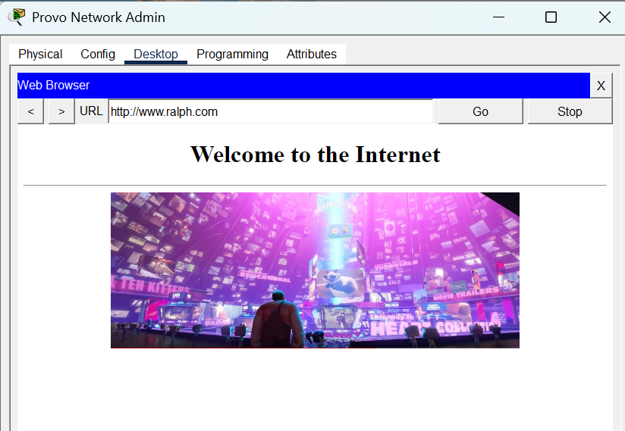 | 1
- Determine the existing Root Bridge for the network. Paste the results below.
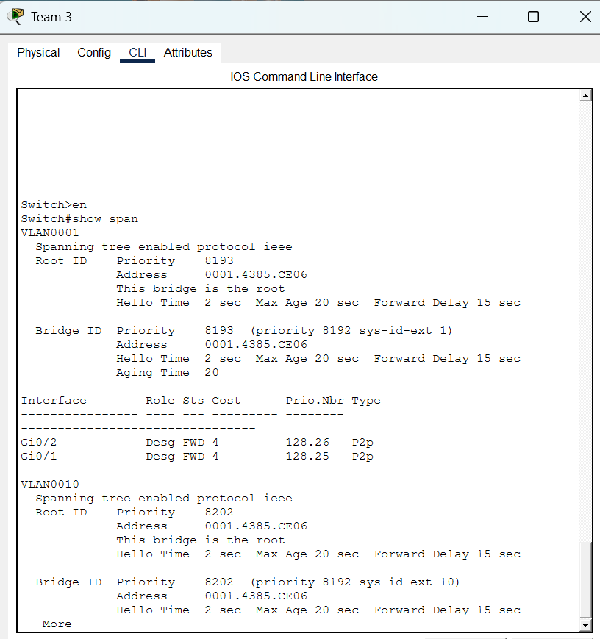 | 1
- Connect ProvoDist switch to the Provo router using a GigabitEthernet port.
- Connect Team 1 switch to ProvoDist switch using 4-cables on ports 21 – 24 on each switch. Configure the 4 ports on each switch as Trunk Ports using the interface range command. Notice that STP blocks 3 of the 4 ports.
- While in the (config-if) mode, create an EtherChannel group using PAGP. When completed, all ports should unblock. Take a snip of the topology between the two switches and paste below.
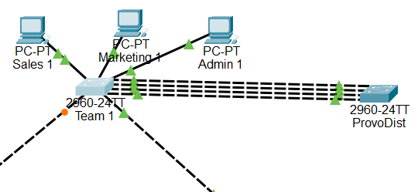 | 3
- Configure subinterfaces on the Provo router to support the management VLAN for the switches and the Sales, Marketing, and Admin VLANs using these assignments:
Interface | VLAN | IP Address | Encapsulation
gi0/0 | N/A | no ip address | none
gi0/0.1 | Sales | 192.168.1.1 | dot1q
gi0/0.2 | Marketing | 192.168.2.1 | dot1q
gi0/0.3 | Admin | 192.168.3.1 | dot1q
gi0/0.4 | VLAN 1 | 192.168.4.1 | dot1q

- Run the “show run” command on the Provo router. Take a snip of the interface section showing the subinterfaces.
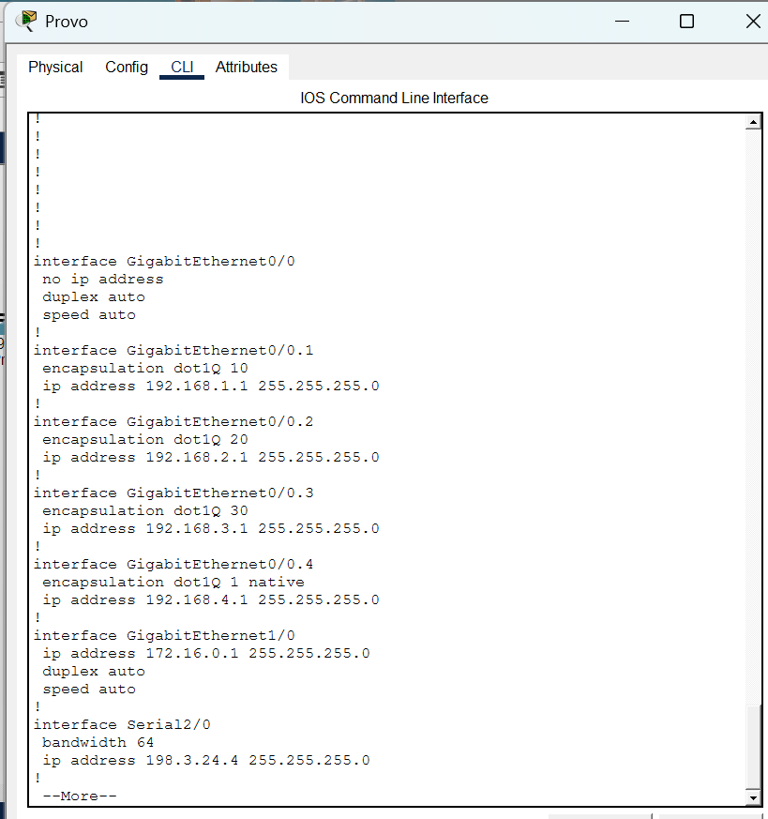 | 2
- Add the default gateway information to each of the VLAN PCs. Attempt to ping the default gateway from any of the computers. It will fail. Try to troubleshoot the reason before continuing. PAUSE . . . Hint: A switch can’t pass a VLAN it doesn’t support. Compare the “show vlan” command on Team 1 and compare it to Provo Dist. What is missing?
- Add the VLANs to ProvoDist. You can do this manually or make the switch a VTP client. Refer to last week’s worksheet for instructions. Ping the gateways from the PC’s. It should succeed. Take a snip from Admin 3 with the successful ping.
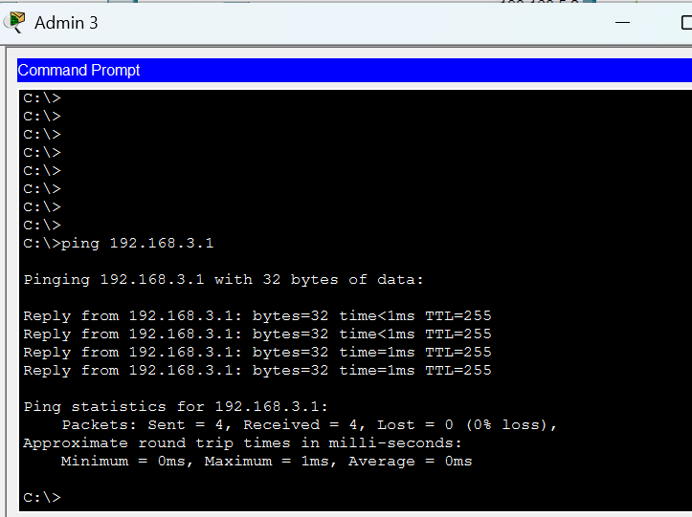 | 3
- Open the Marketing 2 PC Web Browser. Attempt to access the internet by entering 198.168.5.2 in the address bar. This should fail. What could be causing this? The Provo router knows about all the added networks and knows about the internet network using RIP. You need to add the added networks to a routing protocol. When done, execute the “show run” command and snip the routing configuration and paste below. The webpage access should now succeed. Open the ISP router and enter “show ip route”. The routes added on Provo should be visible on the ISP router.

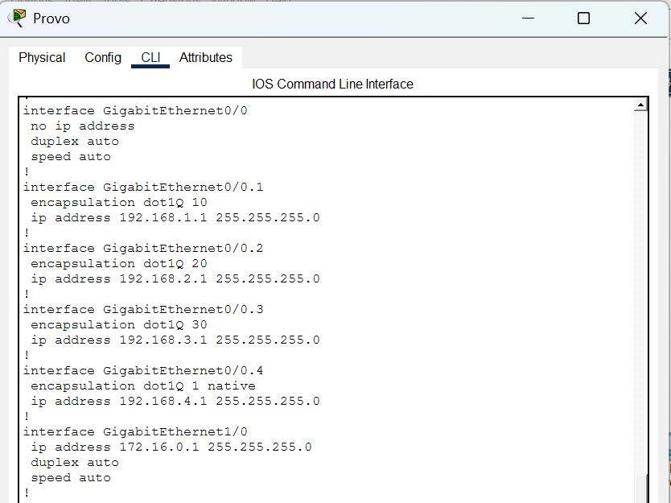 | 2
- From Sales 3, open the web browser and attempt to access “www.ralph.com”. It will fail. Why? Fix the problem. You should now be able to access both www.ralph.com and www.company.internal. Take a snip of the successful access and paste below.
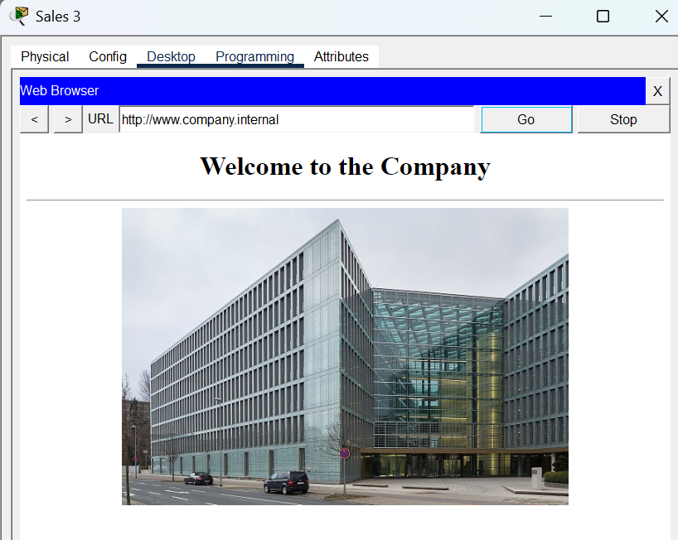  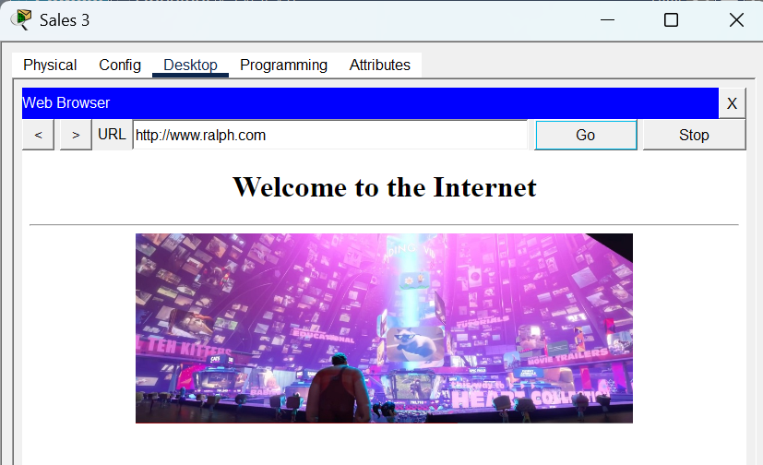 | 2
- Configure a VLAN 1 address and default gateway (192.168.4.1) on all the switches. Use 192.168.4.2 through 192.168.4.5 for the addresses. From any switch or router, you should be able to ping any other device.
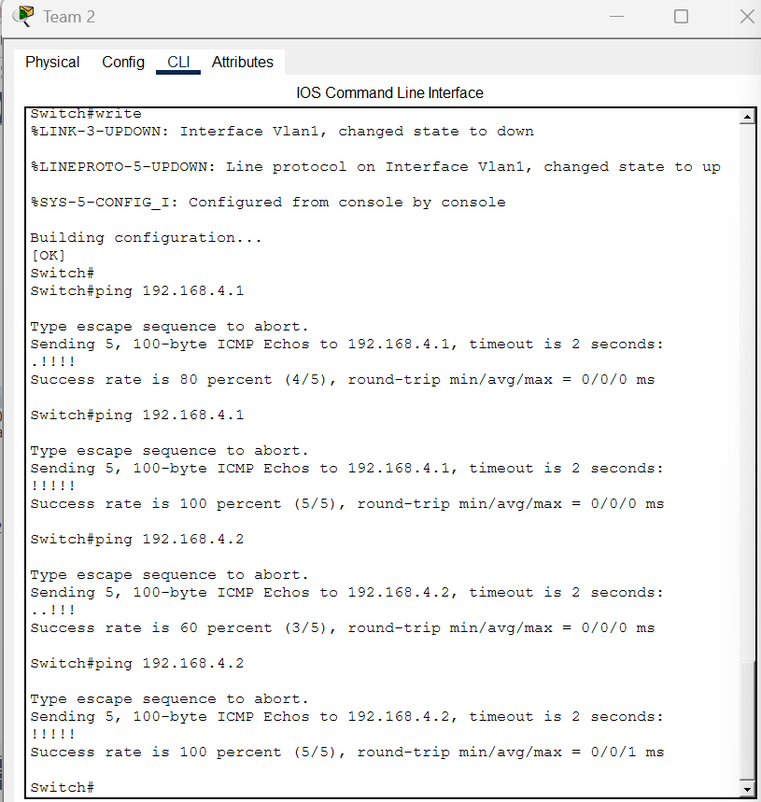 | 2
- Configure DHCP on the Provo Router to support the 192.168.4.0/24 network. Use 192.168.4.1 for the default router and 172.16.0.6 as the DNS server. Don’t forget the excluded addresses. You should have configured ports 13 – 16 on each switch to be on VLAN 1, if not already done. Run the “show vlan” command to confirm port assignments. Add a PC to any Team room. Connect it to a port between 13 and 16. Configure the PC for DHCP. After a short time, the PC should receive a DHCP assignment. Take a snip of the assignment and paste below.
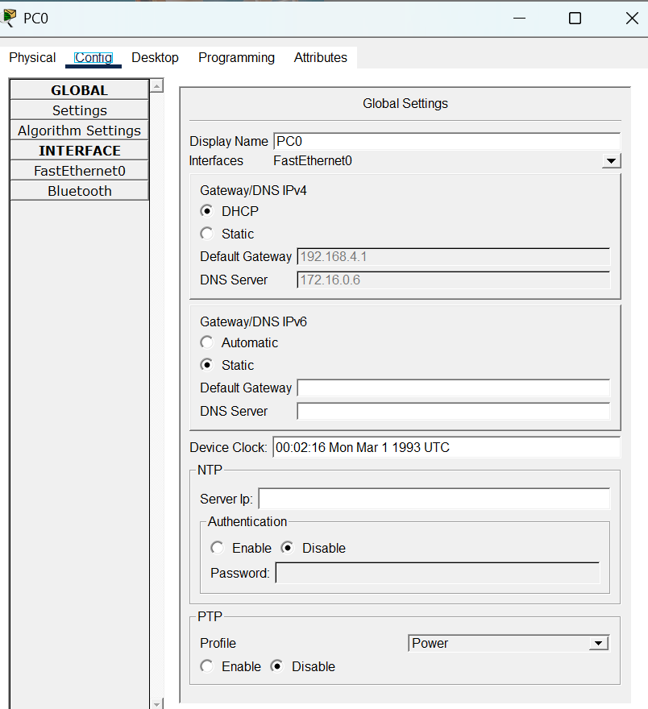 | 2
Open a command prompt on Provo Network Admin. Attempt to telnet to Team 3 (use the VLAN 1 address for the destination address. It will fail! Add the required configuration the switches to enable remote management. When you open a successful telnet session, take a snip of the switch access and paste below.
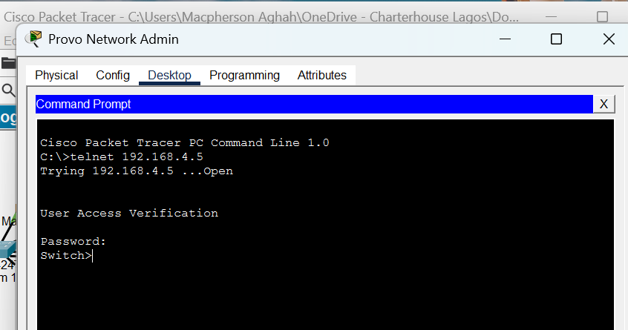 | 2
Total Points | 20

